|  |  |
| --- | --- |
| **EditManagerController** | |
| **Physical address** | admin/application/controllers |
| **Base class** |  |
| **Attributes** | |
| N/A | |
| **Operations** | |
| index() | |
| **Return Type** | void |
| **Parameters** | N/A |
| updateInfo() | |
| **Return Type** | void |
| **Parameters** | N/A |

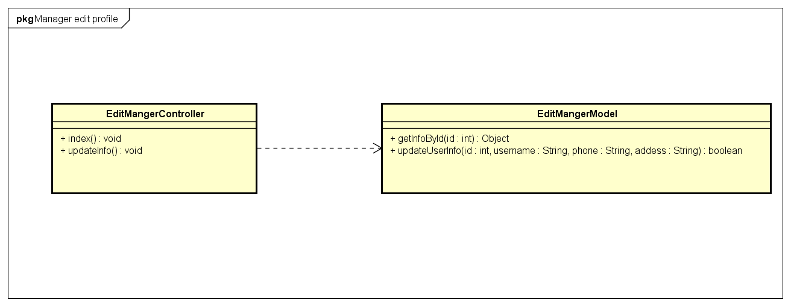

|  |  |  |  |
| --- | --- | --- | --- |
| **EditManagerModel** | | | |
| **Physical address** | admin/application/models | | |
| **Base class** |  | | |
| **Attributes** | | | |
| N/A | | | |
| **Operations** | | | |
| getInfoById() | | | |
| **Return type** | object | | |
| **Parameters** | **Name** | **Type** | **Description** |
|  | Id | Int | User id |
| updateUserInfo() | | | |
| **Return type** | object | | |
| **Parameters** | **Name** | **Type** | **Description** |
|  | Id | Int | User id |